**INTEGRATING COMMINGLING INTO THE STRATEGIC WASTE ROCK PLANNING AT ANTAMINA MINE**

Christa Quiroz1, David Machin1, Olimpia Cabrera1, Fernando Angeles1

1 Antamina Mine, Lima, Peru

(*Presenting author: cquirozc@antamina.com)

**ABSTRACT**

Antamina is a large open-pit polymetallic mine in Peru, operating with a processing capacity of 145 ktpd. In operation since 2001, the current mine life extends to 2036. Mining is conducted at a rate of 290 Mtpa using conventional truck-and-shovel equipment. This technical paper presents a comprehensive assessment of commingling as a transformative technology in mine planning, positioning waste rock and tailings management as a key factor in the decision-making process. The primary objective of this study is to demonstrate the benefits of this technology within the mine planning process, highlighting waste rock and tailings management as one of the main drivers in strategic decision-making. The methodology applied is a Comparative Case Analysis, which includes a review of the design and sequencing process for mining infrastructure such as waste rock storage facilities, along with a discussion of the key parameters considered. The results show that the implementation of this technology delivers significant economic benefits, including an approximate 30% reduction in capital costs for waste rock storage facilities, improved land-use efficiency, and optimized infrastructure development. Furthermore, the approach enhances alignment with the Global Industry Standard on Tailings Management (GISTM).

**KEYWORDS**

commingling, mine planning, waste rock management, tailings management, GISTM compliance

# INTRODUCTION

The mining industry faces growing challenges related to the sustainable management of waste rock and tailings, especially after catastrophic events such as those that occurred in Brumadinho and Samarco (Green Policy Platform, 2024; ICMM, 2020). In this context, the Antamina mine, operating since 2001 as one of the largest polymetallic operations in the world, has developed a pioneering approach that integrates commingling as a central element of its strategic planning (Wheaton Precious Metals, 2015).

Commingling, defined as the homogeneous mixing of dewatered tailings with waste rock to form a geotechnically stable material, represents a natural evolution of traditional co-disposal practices (Burden & Wilson, 2023). However, what distinguishes the Antamina case is the integration of this technology from the initial phases of mine planning, making waste rock management the main driver of operational and strategic decisions.

# OBJECTIVES

* Demonstrate the benefits of integrating commingling into mine planning, positioning waste rock and tailings management as a strategic driver for decision-making in open-pit operations.
* Optimize operational efficiency and environmental sustainability through the adoption of commingling in waste rock and tailings management.
* Align waste rock and tailings management with international sustainability and safety standards, such as the GISTM, through the application of commingling.
* Analyze, through comparative case studies, the impact of commingling on land-use optimization and mine life extension.
* Reduce capital and operating costs associated with waste rock and tailings disposal by implementing commingling technologies.
* Present the key findings and lessons learned from the integration of commingling into long-term mine planning.

# TECHNICAL FOUNDATIONS OF COMMINGLING IN MINE PLANNING

## Desing Principles and Material Characterization

Commingling at Antamina is based on engineering principles that seek to combine the superior structural properties of waste rock with the low permeability characteristics of tailings (Boshoff, 2023). This combination results in a material with shear strength similar to waste rock and permeability comparable to tailings, creating conditions that restrict oxygen entry and water filtration, significantly reducing the potential for acid drainage generation (Ulrich & Coffin, 2015; Burden & Wilson, 2023).

The characterization of commingled material is performed through analysis of five distinct structural configurations: rock-dominated uncompacted, fines-dominated uncompacted, rock-dominated compacted, fines-dominated compacted, and the "just-filled" configuration where fines exactly fill the voids between rock particles (Burden & Wilson, 2023). This latter configuration represents the optimal target of the commingling process at Antamina.

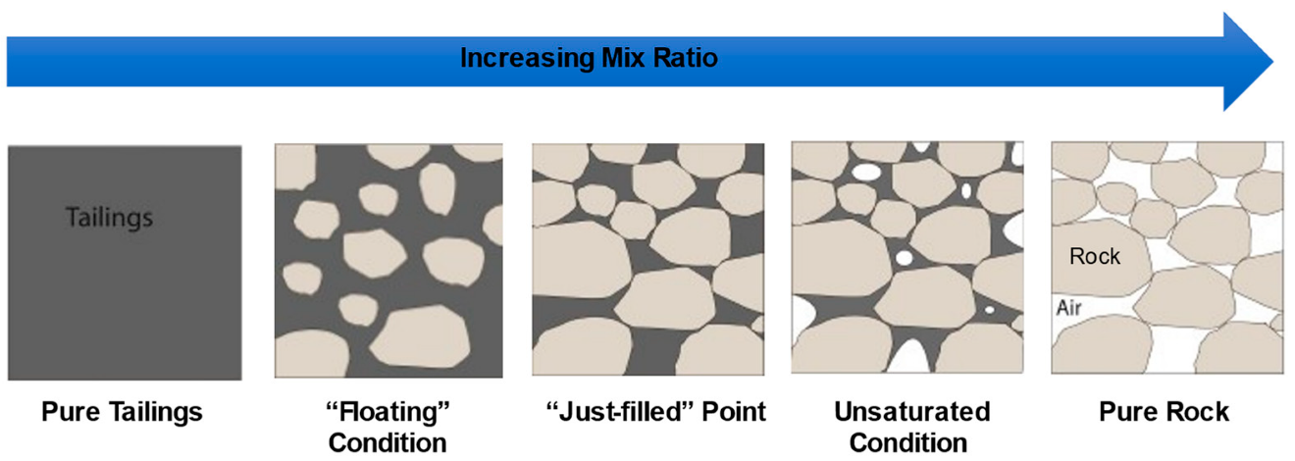

Figure 1 Blend configurations after Wickland et al. (2006). Source: Burden & Wilson (2023).

## Integration into the Strategic Planning Process

The integration of commingling into Antamina's mine planning follows a structured methodological approach that places tailings management with waste rock as central elements of decision-making. This global strategy allows for optimizing the mixture of materials from the mine to the plant, considering the operational and environmental constraints associated with the tailings storage facility. By incorporating tailings behavior in the early stages of planning, greater efficiency in resource use and better risk management are achieved.

The global strategy is divided into three key axes:

* **Strategy 1: Ensure Future Expansions:** The first strategy focuses on maximizing tailings storage capacity for current and future needs, leveraging Antamina's mineral resource and applying advanced technology to increase TSF (Tailings Storage Facility) capacity to ensure the mine's long-term operational continuity.
* **Strategy 2: Optimized footprint:** The second strategy seeks to optimize the overall project footprint by balancing waste and tailings storage space. This approach aligns directly with commingling principles by maximizing efficient use of available land within the current operational footprint.
* **Strategy 3: Reduce upfront CAPEX:** The third strategy focuses on reducing initial CAPEX to improve key financial indicators (IRR), which directly aligns with the demonstrated economic benefits of commingling, minimizing operational costs with a nearby TSF and optimizing CAPEX timing.

**Tailings Strategy**

**Strategy 1:**

Ensure Future Expansions

**Strategy 2:**

Optimized Footprint

**Strategy 3:**

Reduce upfront CAPEX

Upside

Regular Model

Optimized Pit

Potential Pit

**Objetive**

Suboptimal Pit

Maximize tailings storage capacity current and future needs

**Challenge**

- Engineering level required for each study phase

- Higher initial CAPEX

- Reduced space available for waste dumps.

Optimize overall project footprint by balancing waste/tailings storage space

- Requirement to develop detailed phasing sequences.

- Engineering level required for each stage.

Reduce upfront Capex to improve financial KPI (IRR)

-Shorter mine-life

Regular Model

Upside

**Resource**

Figure 2 Strategic vision of mine planning approach with commingling

The strategies implemented in tailings dam and waste dump management seek to maximize the operational life of the mine and optimize asset value. These decisions translate into concrete actions that address sustainability, operational efficiency, and cost reduction, ensuring continuity and long-term success of the mining operation.

* **Long Life Asset:** Antamina's vision as a long-life asset involves making decisions based on sustainable exploitation of its exceptional mineral resources. This includes adopting advanced technologies, such as commingling, to improve storage capacity and ensure operational continuity until 2036 and beyond, thus maximizing the value of the mineral resource.
* **Reduce Environmental Social Footprint:** The strategic approach prioritizes reducing environmental and social impact through operation within the current footprint, increasing water availability through filtration, optimizing space use, and minimizing risks associated with tailings dams. Commingling contributes not only to technical and economic efficiency but also to sustainability objectives and corporate social responsibility.
* **Reduce Capital and Operational Cost:** The cost reduction strategy focuses on optimizing capital investments (CAPEX) and their schedule, as well as minimizing operational costs through strategic facility location and leveraging synergies to avoid duplicate infrastructure. This enables more efficient and profitable resource management.

During the strategic planning phase, conceptual foundations for commingling implementation are established, including site characterization, regulatory framework development, and technical-economic feasibility analysis.

# ANALYSIS OF THE MINING SYSTEM WITH COMMINGLING APPLICATION

## Methodological Process Structure

The methodological process is organized in sequential stages that ensure effective integration of commingling into mine planning:

* **Comprehensive material evaluation:** Detailed analysis of geotechnical and geochemical characteristics of available materials, identifying their suitability for mixtures and joint disposal.
* **Mixture design development**: Design of optimized mixtures that maximize desired properties of commingled material, such as low permeability and high stability, minimizing acid water generation and improving mechanical behavior of the deposit.
* **Pilot test implementation:** Execution of pilot and industrial scale tests to validate mixture performance and adjust design parameters according to results obtained under real operating conditions.
* **Monitoring and adjustment:** Establishment of continuous monitoring system to evaluate consolidation, stability, and geochemical behavior of deposits, allowing operational and design adjustments as new information is collected.

# IMPLEMENTATION AND EVALUATION METHODOLOGY FOR COMMINGLING IN MINE PLANNING

## Comparative Case Analysis

The methodology applied at Antamina is based on Comparative Case Analysis, allowing for comprehensive review of the design and sequencing process of mining infrastructure, with emphasis on dams, waste rock dumps, and integration of commingling technologies. This methodological approach comprises:

* **Review of design and sequencing processes:** Analysis of procedures used in waste dump planning and disposal, considering both geotechnical and geochemical criteria to ensure infrastructure stability and sustainability.
* **Identification of key variables:** Selection of fundamental operational parameters, such as granulometry, permeability, geochemical behavior, and storage capacity, which directly affect the viability and performance of dumps and material mixtures.
* **Definition of case tree:** Structure of a decision tree that contemplates long-term strategic scenarios, allowing comparison of alternatives under different combinations of variables and operational constraints.
* **Results evaluation:** Application of sensitivity analyses and cost-benefit evaluations to determine the impact of each alternative on mine life extension, environmental risk reduction, and resource optimization.

## Decision Tree for Strategic Planning

The decision tree developed for long-term strategic planning at Antamina follows sequential logic that allows evaluation of feasibility and impact of main operational alternatives:

* **Commingling feasibility:** The first node of the tree determines whether integration of tailings and waste rock is technically and economically viable, considering material characteristics and regulatory constraints.
* **Entry into new area:** If commingling is feasible, the next node evaluates the possibility of disposing material in a new area, analyzing topographic, environmental, and access aspects.
* **Need for new dam:** Finally, it determines whether construction of a new tailings dam is essential or if the commingling solution allows dispensing with this infrastructure, optimizing investment and reducing environmental impact.

Each of these decisions conditions mine life extension, efficient space use, and environmental risk management, allowing selection of the alternative that maximizes economic, social, and environmental value of the project.

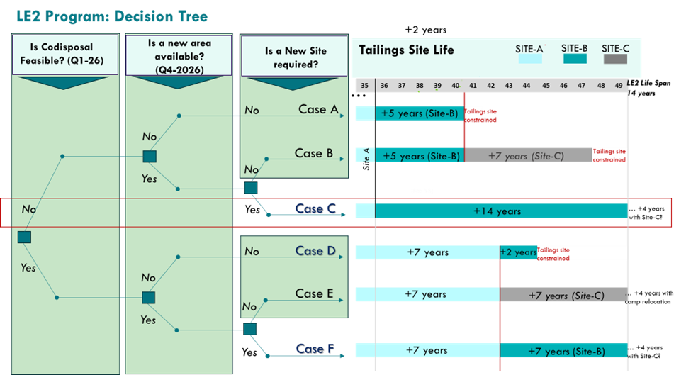

Figure 3 Decision Tree for Long-Term Strategic Scenario Planning

## Evaluation of Operational Parameters and Modifications by Commingling

Key operational parameters—including waste rock-tailings ratio, mixing methods, transport systems, and processing criteria—are assessed for their impact on commingled system efficiency. The evaluation considers site-specific challenges such as extreme Andean weather, high-altitude logistics, and Peruvian regulations, all of which are especially critical at Antamina and require customized commingling solutions.

* **Modifications to tailings management by commingling:**

The commingling process fundamentally transforms tailings management by utilizing voids within waste rock for storage, with available space typically equivalent to about 20% of the crushed rock volume transported by conveyors. To enable mixing, tailings must first be dewatered. The following image shows both the current process (without mechanization) and the transformation that occurs when commingling is incorporated.

**DUMP**

**DAM**

**Mining Process including Commingling**

Commingling

*t*

T = generated tailing

c

Crusher

waste

**DUMP**

K = Waste

(Trucks)

**DAM**



Concentrate

Ore

Rock

M: Mine

P : Plant

T = generated tailing

**Current Process**

**(no Mechanization included)**



Tailing dewatering by Commingling

Fines Tailings

Coarse Tailings

**PIT**

M

P



Concentrate

Ore

Rock

M: Mine

P : Plant

K=Waste (Trucks)

**PIT**

**M**

**M**

**Mixing Point**

c

T

**P**

**P**

Figure 4 Transformation of Tailings Management: Evolution from Conventional Process to Commingling|

* **Operational parameters and assumptions**

Commingling extends tailings facility life by optimizing spatial use of waste rock voids. Implementation requires mechanized systems (WCCS) for transporting crushed material mixed with dewatered tailings, while maintaining two key operational parameters: **a)** **Unchanged transport capacity**: 83.2 Mtpa in the conveyor system and **b)** **Volumetric stability**: No increase in total volume of waste rock dump.

This approach ensures efficient resource utilization and supports sustainable mine operations.

Table 1: Key operational parameters and assumptions

| **Component** | **Units** | **Without - Case Conventional** | **With - Case Commingling** |
| --- | --- | --- | --- |
| Cycloned/Filtered Max. Capacity | Mtpa | - | 32.0 |
| Percentage of Voids in Waste Rock | % Volume |  | 20 % |
| Waste Rock / Tailings Ratio | Mt Rock/  Mt Tails | - | 83 / 16 |
| Conventional Tailings Density | t/m3 | 1.81 | 1.81 |
| Fines Tailings Density | t/m3 | NA | 1.60 |
| Tailings Volume, TDR 4195 (to Dic-22) | Mm3 | 376 | 376 |
| Tailings Capacity, TDR 4195 (to Dic-22) | Mt | 682 | 652 |
| Mill Feed Rate | Ktpd | 145 | 145 |

The following image shows how incorporation of mechanized systems and commingling add capacity, and therefore extend tailings facility life, to increase the life of mine and therefore the overall asset value.

Figure 5 Commingling Extension of Tailings Facility Life through Commingling

The curve below shows the relationship between dry density and optimal mixing proportion, determinant for maximizing commingling efficiency.

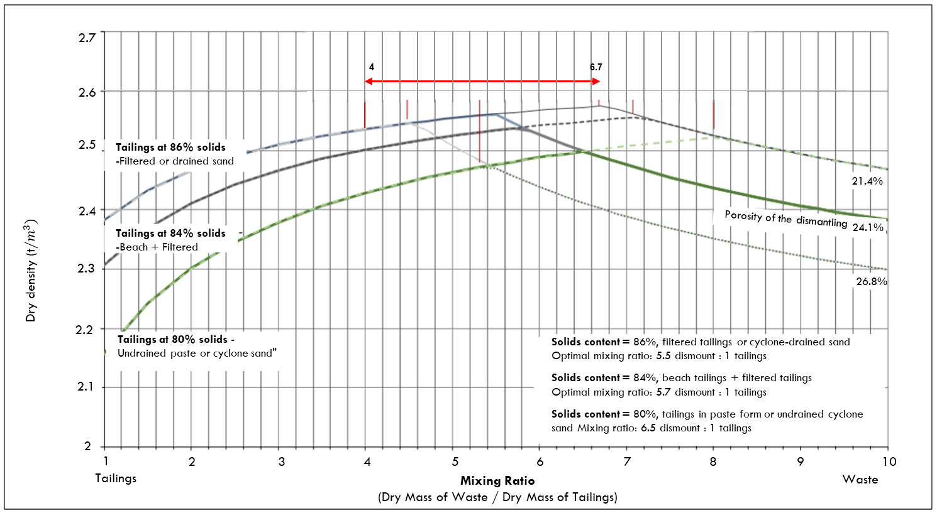

Figure 6: Dry density curve vs. optimal mixing proportion for commingling

* **Analysis of Mineable Resources, Production and Value**

A three-dimensional diagram is used to strategically analyze the interactions between mineable resource volume, production rate, and generated value—whether economic, environmental, or operational. This tool helps identify how increasing resource volume and production can maximize value, but also highlights key constraints such as tailings dam capacity and property limits. The approach supports comprehensive decision-making to optimize asset value and ensure project sustainability across various operational scenarios.

**Value**

**Resource**

**Ore (volume)**

**Production Rate**

**(Flow Rate)**

140 ktpd

145 ktpd

155 ktpd

150 ktpd

Extension 1

(834 Mt)

Extension 2

(~ 1500 Mt)

Isovalue

curve

**1**

**2**

**3**

**4**

**Constraint – Tailings Dam**

**Constraint – Property**

**No Constraint – Economic Limit**

135 ktpd

Extension 3

(~ 1700 Mt)

Extension 4

(~ 2400 Mt)

**1**

**2**

**3**

**4**

Figure 7 Value Optimization: Interaction between Resource Volume, Production Rate and Key Restrictions

# ECONOMIC AND OPERATIONAL ADVANTAGES

## Perspective of Conventional Value Drivers

The following figure illustrates Antamina's main conventional value drivers from a financial perspective. In the current scenario, the amount of mineral resource that can be utilized directly depends on the capital that the company decides to invest (Capex), both in new investments (Growth Capex) and in maintaining existing operations (Sustaining Capex). This generates a necessary balance to determine the optimal scenario that maximizes the value of the existing asset.

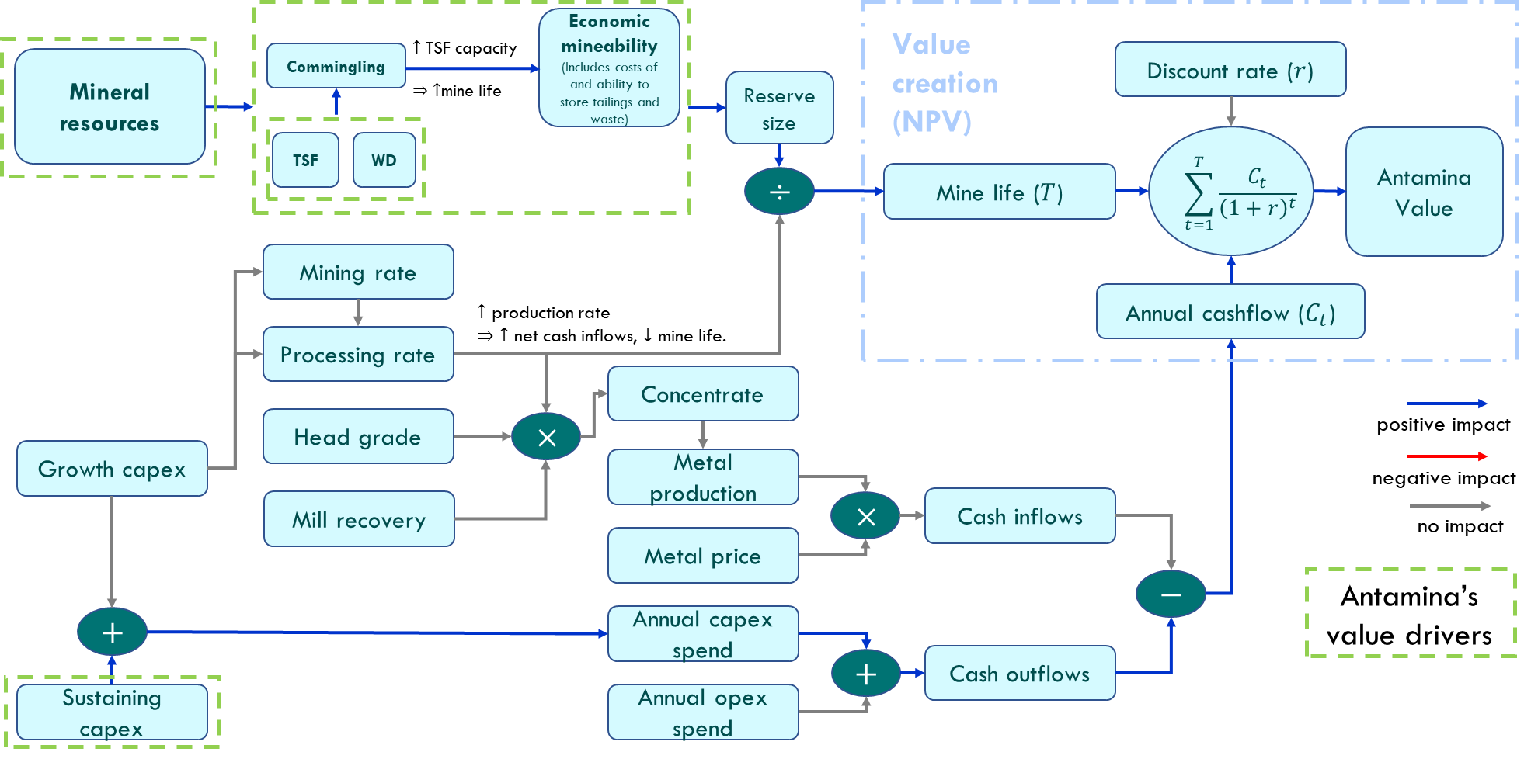

Figure 8: Conventional Antamina Value Drivers: Financial Perspective (Without Commingling)

## Impact of Commingling on Financial Value Drivers

From a financial perspective, the adoption of commingling among Antamina’s value drivers removes constraints on mineral resources by increasing tailings storage capacity, enabling the utilization of new dumps, and allowing for an expansion in the volume of usable resources. As a result, the mine’s operational life is extended and asset value is enhanced. Regarding dump utilization, the implementation of commingling has the potential to reduce the requirement for dumps located in karstic zones, which demand significant capital expenditure (Capex). This can lead to a reduction in initial investment by up to 30% in scenarios comparing commingling versus non-commingling approaches. This saving is achieved through the integration of previously separate infrastructures into a single system, which optimizes the use of available area in the East Extension dumps and prioritizes the use of mechanized systems over conventional trucking methods.

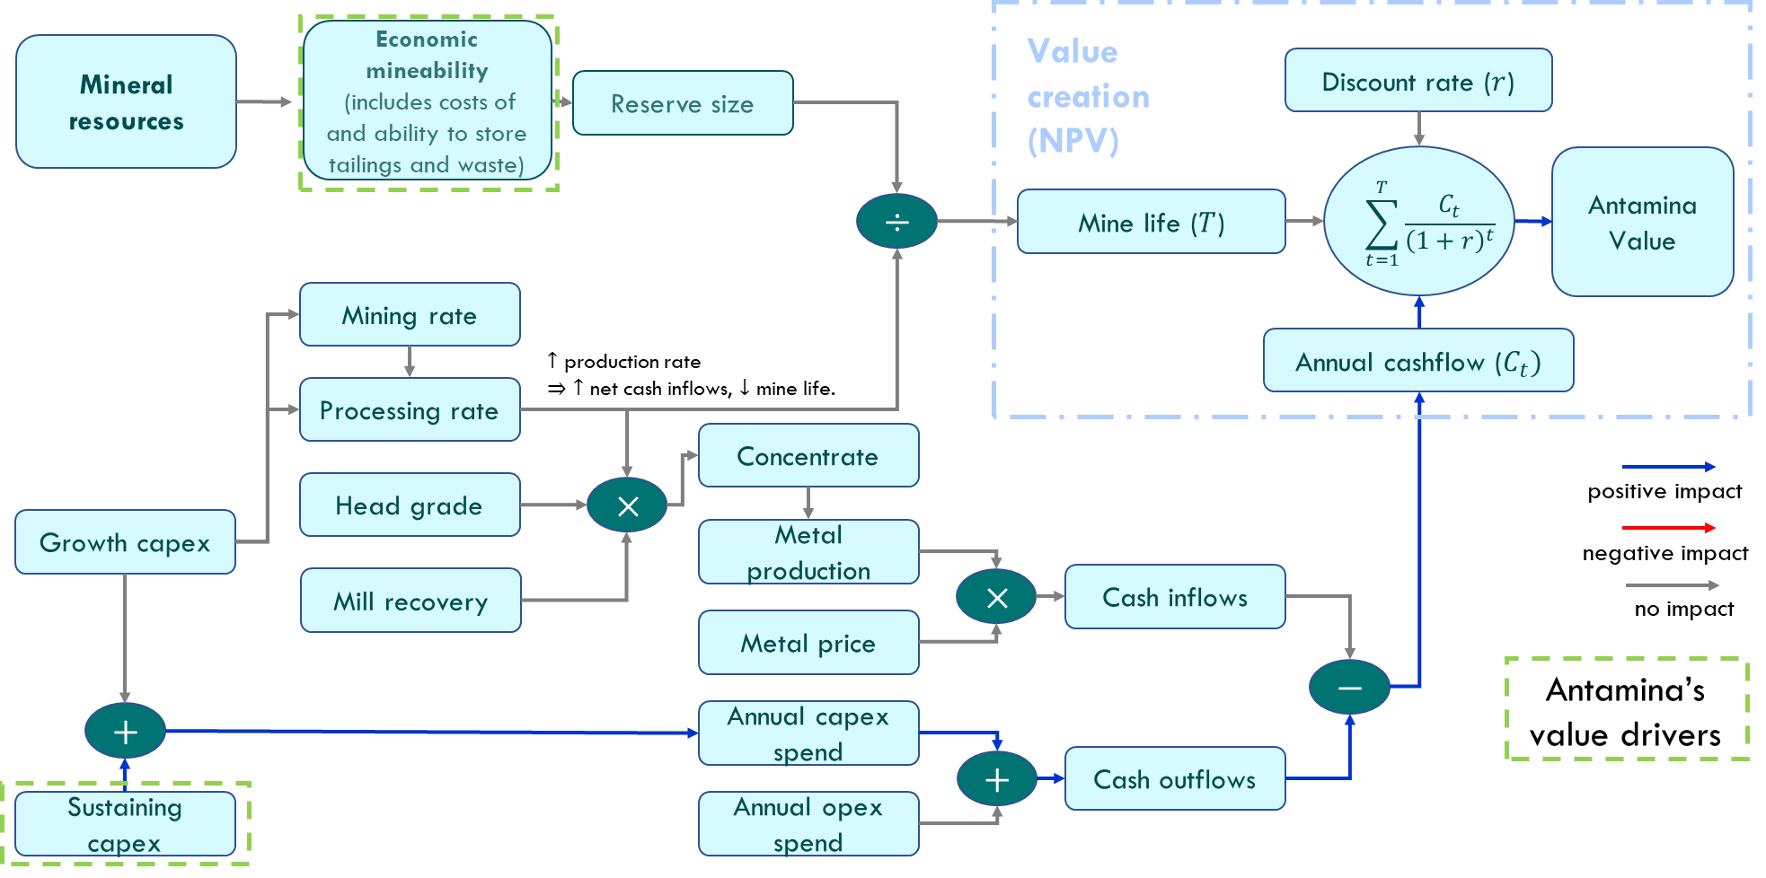

Figure 9: Antamina Value Drivers: Financial Perspective with Commingling

The optimization of land use represents another important economic benefit, especially relevant in mountainous locations like Antamina where available land for mining facilities is limited. Commingling allows for the creation of deposits with a smaller footprint compared to separate facilities, freeing up land for other productive uses or reducing the need for additional land acquisition.

# ALIGNMENT WITH GISTM STANDARDS AND SUSTAINABILITY

The integration of commingling into mine planning strengthens compliance with the Global Industry Standard on Tailings Management (GISTM), by facilitating safer and more sustainable management of waste materials. The GISTM requires the planning, construction, operation, and closure of tailings facilities with a focus on risk reduction and continuous monitoring throughout the lifecycle. Commingling contributes to this objective by improving the geotechnical and geochemical stability of deposits, reducing the risk of failure and acid drainage generation, which in turn reduces environmental impact and long-term treatment costs. Additionally, the consolidation of facilities through commingling reduces the environmental footprint and facilitates supervision and control, aligning with the principles of sustainability and social responsibility in the mining industry.

# LESSONS LEARNED AND CHALLENGES

Among the main lessons learned and challenges of implementing commingling in mine planning at Antamina, the following stand out:

* **Large-scale operations and mechanization:** Commingling is primarily viable in large-volume mechanized operations, where it is possible to achieve a homogeneous and controlled mixture of materials. However, the magnitude of waste rock and tailings tonnages at Antamina implies a new challenge, never seen before.
* **Flexible planning and pilot tests**: It is essential to include areas for pilot tests in short and medium-term plans, allowing adjustment of mixing parameters according to material variability.
* Regulatory **communication:** Technology acceptance requires identifying precedents and working closely with authorities to develop appropriate regulatory frameworks.
* **Organizational change management**: The transition to commingling involves challenges in personnel training and adaptation of operational processes, especially in mature operations.

# CONCLUSIONS

* The comparative discussion and case analysis of commingling implementation at Antamina have enabled the identification and selection of strategic alternatives that maximize the economic, environmental, and social value of the project.
* The use of decision trees and scenario evaluation has facilitated informed decision-making, taking into account technical and economic feasibility as well as regulatory and environmental constraints.
* The integration of commingling into strategic mine planning has proven to be a key tool for optimizing waste rock and tailings management, achieving a significant reduction in capital costs (up to 30%), greater efficiency in land use, and an extension of tailings storage facility (TSF) life. This approach has also aligned operations with international sustainability standards (GISTM) and strengthened risk management, contributing to operational continuity and long-term reduction of environmental impacts.
* The Antamina experience demonstrates that structured case discussions and the application of comparative methodologies are fundamental for strategic planning, as they allow anticipation of challenges, validation of solutions through pilot testing, and adjustment of operational parameters based on real outcomes. Thus, commingling is consolidated as a transformative practice in modern mining, fostering more robust and sustainable decision-making for the development of long-life mining assets.

**ACKNOWLEDGEMENTS**

The authors express their sincere gratitude to Antamina for their invaluable support. Special thanks are extended to the Tailings Strategy Management team and the Long-Term Planning team for their collaboration and insights.

**REFERENCES**

Boshoff, J. et al. (2023). *A case study on the commingling of tailings and waste rock at a Brownfields open cast mine in Ghana.* University of Alberta.

Burden, R., & Wilson, G. W. (2023). *Commingling of waste rock and tailings to improve “dry stack” performance: Design and evaluation of mixtures.* Minerals, 13(2), 295.

Deza, N., & Montes, K. (2022). *Mecanización del desmonte en Compañía Minera Antamina: Propuesta para capturar el valor tangible e intangible de la mecanización*. Compañía Minera Antamina.

Green Policy Platform. (2024). *Knowledge Gaps Report: Environmental Aspects of Tailings Management* (January 2024).

ICMM. (2020). *New global industry standard on tailings management. International Council on Mining and Metals.*

Ulrich, B. & Coffin, J. (2015). *TMW 2015 – Combined Tailings and Mine Waste.*

Minemax. (2015). *Why mine planning is all about collaboration. Minemax News.*

Wheaton Precious Metals. (2015). *Antamina Project overview.*